Walk for Save the Planet
Friday 24th – Sunday 26th September 2021
With world leaders meeting in Edinburgh in November to discuss how to meet the challenge of climate change, SWAY felt it was a good time to walk across the area and focus our minds on the environment, our history and the challenges of caring for our planet.
Andy and Peter joined 11 young people in a walk over the weekend that informed our minds, exercised our bodies and stirred our souls to be better stewards of the planet God gave us to inhabit. We began at Dunsbury Farm, Brook and finished at Stonelands, Niton.
We had a variety of talks along the way which helped us understand something of our Island’s history – burial mounds 1000’s of years old, Vicar’s who fought for the abolition of the slave trade and places of worship that go back 500 years and more, and are roofed with the remains of a shipwreck from Bermuda. We had other talks that focussed on the task of working with nature rather than against it – a common theme – as evidenced in the beautiful Northcourt garden in Shorwell and the busily industrious Stonelands project in Niton.
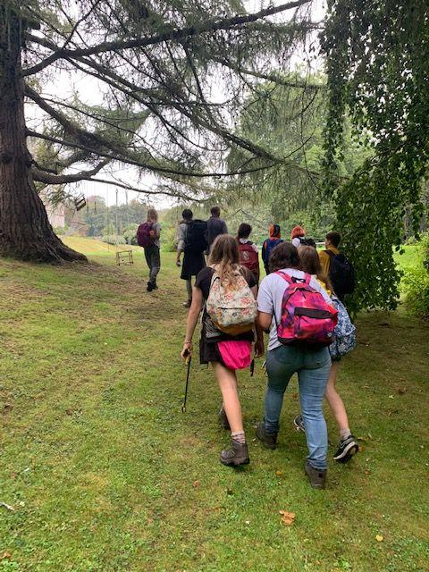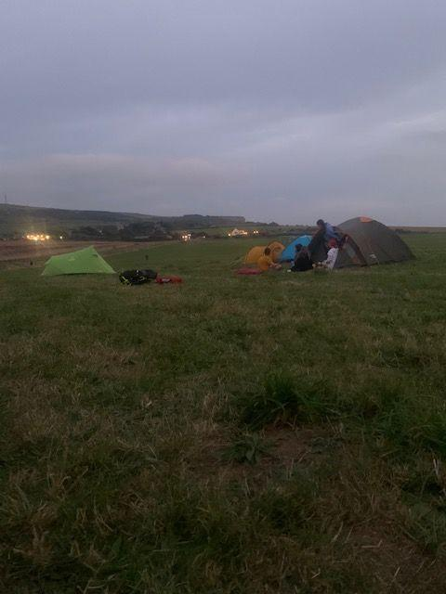
Camping at Grange Farm by the coast and Chale Rec was fun, with mild September nights and pancakes to cheer us up and get us going in the mornings. Pausing at Chale Church on Sunday morning for half an hour of worship was very special in that ancient place. A number of local folk joined us as we dropped bags and lifted voices to the God of creation who fills the earth with His glory and beauty.
Covering 30 miles by foot, there was a real sense of journeying and arriving at Stonelands, Niton, gave weary feet the feel of accomplishing something important. We may not have changed the planet, but perhaps we may have a better understanding of its richness, its history and the challenge we have caring for it.

